Where Penkridge Bank meets Harley’s Corner.

Where on Cannock Chase is Harley’s Corner?

Harley’s Corner is at the junction where Penkridge Bank Road meets the Stafford Brook Road. Here a Mr Ernie and Mrs Annie Harley used to live in the cottage Hoar Cross View which is close to this junction. When the Wheeldon’s Green Bus came to this junction the driver would shout ‘Anyone for Harleys Corner? ’ but today it is little known.

I would like to tell you a little information about this area.

‘Aldene’ is the first cottage in Stafford Brook Road, built in 1845. It is named after an Alice and Dennis who lived here. Previous to the cottage being called ‘Aldene’ the house was known as ‘Hoar Cross View’, this was due to Hoar Cross been seen in the distance. The cottage was also used as a pay office for the miners at nearby Fair Oak Colliery. The colliery was operational between the years 1871-1884. Next door lived Alice’s parents, Harry and Alice. Their house was called ‘Haral’ again taking part of their names. ‘Haral’ was also built in 1845. Previous to the cottage been called ‘Haral’ it was named ‘Blithfield View’, as Blithfield Hall was visible.

Both cottages were built by the Marquis of Anglesey who at this time owned the land. Harry and Alice first met as they lived near to each other. Harry living in ‘Penkridge Bank Cottage’ and Alice in the cottage ‘Hoar Cross View’.

During the Great War, Cannock Chase was used as a military training camp. On the corner of Penkridge Bank Road, Stafford Brook Road stood the ‘Tipperary Tea Rooms’, a chip shop, and a photography studio, providing a service to passing troops. Next to these buildings stood ‘Penkridge Bank Cottage’ and ‘Hickory House’ which were built in 1879.

‘Hickory House’ was built by Edward Dukes. Its full name which is displayed above the doorway is ‘American Shellbark Hickory House’. Edward was a lawyer’s clerk in Rugeley but was dis-satisfied with his job and longed to seek work in the outdoors. When the railways came to Rugeley it gave him the opportunity to work outdoors as a railway labourer. He had the urge to travel and went off to America. Whilst there he worked as a lumberjack cutting logs which were to be made into railway sleepers. He lived in a log cabin built from the Shellbark Hickory tree (a type of walnut tree). Some years later he returned to Rugeley and purchased land from the Marquis of Anglesey paying £194 for two adjoining plots. Edward had the two identical cottages built for himself and his son, both supplied with water from their own well.
At the same auction at the Shrewsbury Arms Hotel, in Rugeley a Mr Walter Noble Landor (founder of the Landor Local History Society) bought 8 acres of the surrounding land. Some of this land now belongs to Penkridge Bank Cottage, some belonging to Shooting Butts School.

The Manton family owned a taxi service in Rugeley, as well as a fish- monger, green grocer and game and poultry shop. They had two daughters Florrie and Annie. When the daughters married they lived in ‘Penkridge Bank Cottage’ and ‘Hickory House’.

During the war years the Manton daughters took the opportunity to open a tea room on the corner plot of their land (Harley’s junction.) This was the ‘Tipperary Tea Rooms’ supplying refreshments to the troops travelling from the camp to Rugeley or Hednesford. There was also a chip shop and photography studio. The photography studio was possibly rented by Alfred Bates who also owned a studio in Anson Street Rugeley. He was well known for his portrait photos taken of soldiers. A number of photos still survive with Alfred’s stamp on the back of the photo.

Stafford Brook Road
Tipperary
Tea Rooms
Chip
Shop
Photo
Studio

Penkridge
Bank
Cottage

Hickory House

Aldene

Haral

Penkridge Bank Road

Harley’s Corner

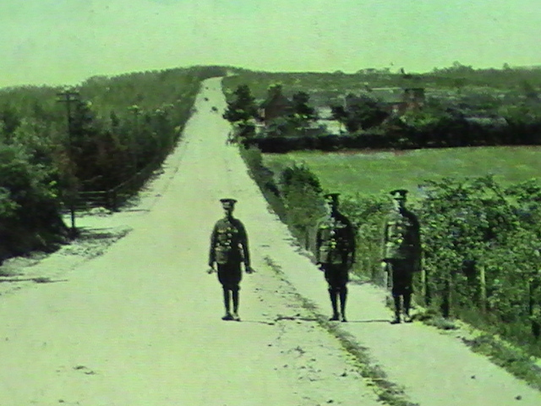

Soldiers on Penkridge Bank, the road on the left is Birches Valley, Penkridge Bank plantation. The buildings in the distance are at the junction of Harley’s Corner.
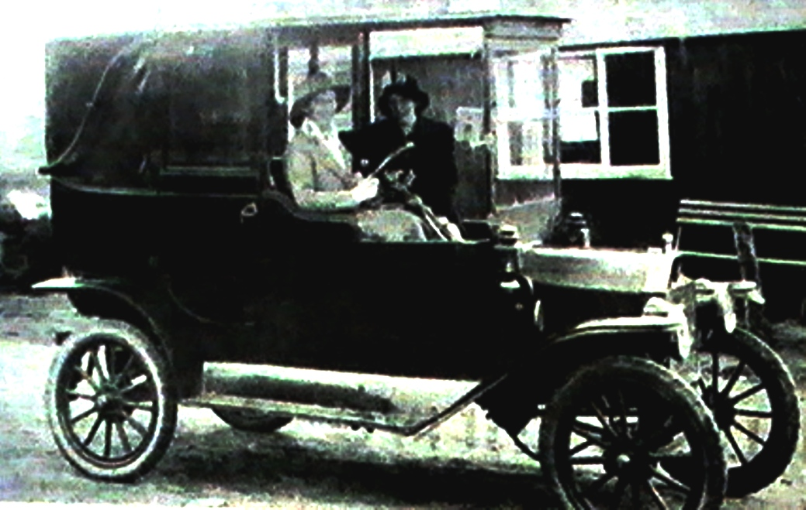

Miss Vera Aucott with a friend on her day off. She had the loan of the taxi for the day and is shown outside the ‘Tipperary Tea Rooms’ on the junction of Penkridge Bank Road and Stafford Brook Road.

The ‘Tipperary Tea Rooms’, possibly owned by the Manton family. The sign above the door reads that it is run by A. Beach, licensed to sell tobacco . Outside the building there are benches and tables for the soldiers to sit on. The driver is Fred Manton, the Manton’s eldest son. Fred is driving a Studebake taxi. In the distance you can see a small building. This building still stands in the grounds of ‘Aldene’ cottage.
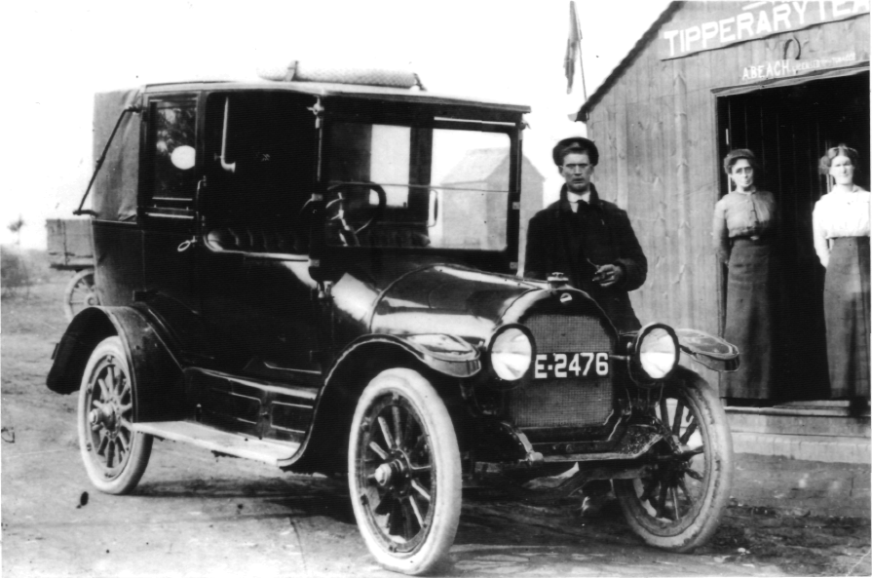

In the book ‘A Town For Four Winters’ it says that “Many ordinary people managed to make a little money out of the troops by providing teas for wandering groups of soldiers and their girls. Much more profit was made by providing accommodation for soldiers’ wives and parents on a temporary basis. Often a soldier could not get leave especially when his draft was going to France at very short notice and the only way to see his loved ones, very often for the last time, was to find a room locally. It is certain that there were good-hearted local people who would willingly give a bed free for a nominal sum in these circumstances, but it is also true that many people charged exorbitant rates.”

Acknowledgments and Sources

The author would like to thank Mrs A Birch as without her information this article would not be possible.
The Landor Society for the kind loan of the photos and information.
Brenda and Ken Edwards
Clive and Juliet Blick
‘A Town For Four Winters’ - C.J and G.P Whitehouse

